5-Star Analysis Tutorial

This tutorial was originally created by Aaron Price for the Citizen Sky 2 workshop. It has since been updated by Paul York to reflect changes to the VStar software since that time.

Looking at a Light Curve

What is a light curve? Light curves are a fundamental tool for variable star astronomy. They are relatively simple and easy to grasp. They are simply a graph of brightness (Y-axis vs X-axis). Brightness increases as you go up the graph and time advances as you move to the right. Here is a light curve of epsilon Aurigae from a recent eclipse:

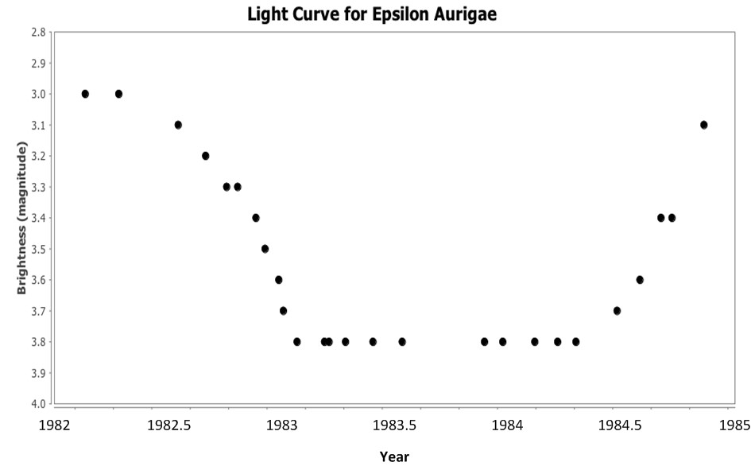
Each of the data points on the left is a single brightness estimate of the star made by an amateur astronomer

This light curve shows that the star began at a brightness of magnitude 3 in 1982. Around mid-year it began to rapidly dim until it reached a brightness of magnitude 3.8 at the end of the year. It remained there until the beginning of 1984 when it began a slower climb back to normal brightness. By the middle of 1984, it was almost back to normal brightness.

The above light curve was idealized, in that it was processed to include only the best observations to make it clear. Now let’s look at a more complicated, real-world light curve. Here is a light curve of the bright star Betelgeuse (aka Alpha Ori to astronomers) in the constellation Orion.
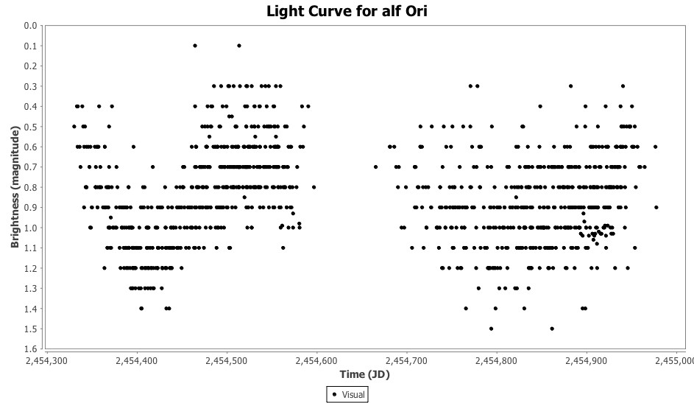

Each dot in this light curve is a visual observation of the star submitted to the AAVSO International Database (AID). The numbers on the X-axis are Julian Dates. That’s a standard format that astronomers, especially variable star astronomers, use to record dates: roughly speaking, all dates in the Julian Date system are expressed in terms of the number of days that have elapsed since noon (GMT) on January 1, 4713 BCE. (For more information see http://en.wikipedia.org/wiki/ Julian_day). The light curve above covers observations made from around mid-2007 to mid-2009.
Notice that there are many observations made on the same dates. But sometimes they don’t agree! That’s because we’re all human and so will make different estimates of a star’s brightness. We chose this star as an example because it is very bright and very red. This makes it extra hard for humans to make consistent observations. We call this variation in brightness estimates scatter.

Mean Curves

Here is the same light curve, but with a mean curve drawn through it.
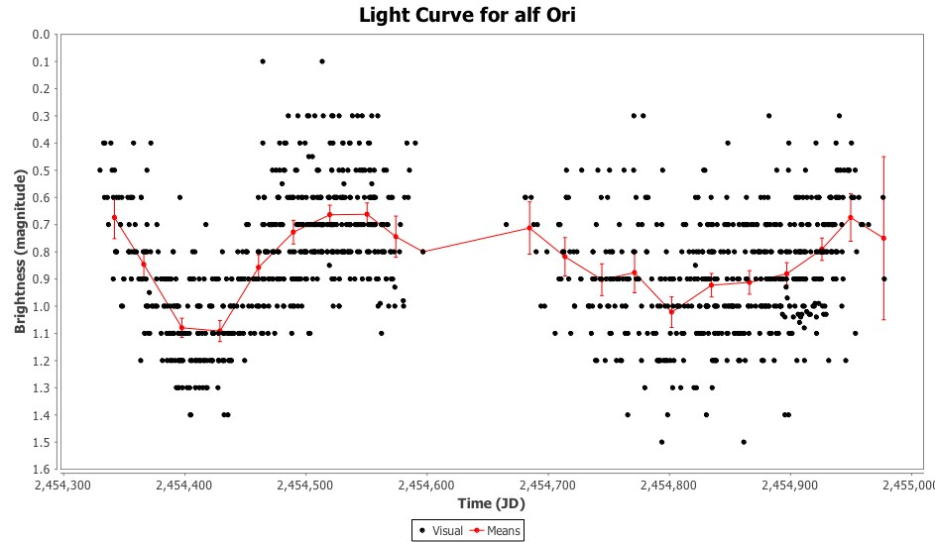

The red line reflects the average observation made at that time. More precisely, we calculated an average brightness of the star in 30-day increments then drew a line between the average points. The vertical red bars you see along the line are error estimates. It’s a statistical value that provides an idea of how much you can trust the red line. (There is a 95% chance that the real data value falls on that vertical bar - a common benchmark that scientists use).
A good rule of thumb is to see whether you can draw a straight, horizontal line that intersects all the error bars. If you cannot draw such a line, then you can be confident the variation is real. If you can, it means there is no clear variation in the data. There may still be real variation, but you’ll need more analysis to prove it. Notice that you cannot draw such a line through the first set of data in the light curve above. However you can draw one through much of the data in the second set. The second set is noisier (ie. it has more scatter) and we are less confident that it shows variation.

Make Your Own Light Curves - Web

There are two free variable star light curve generators you can use. One is on the AAVSO website and the other is a downloadable Java application.
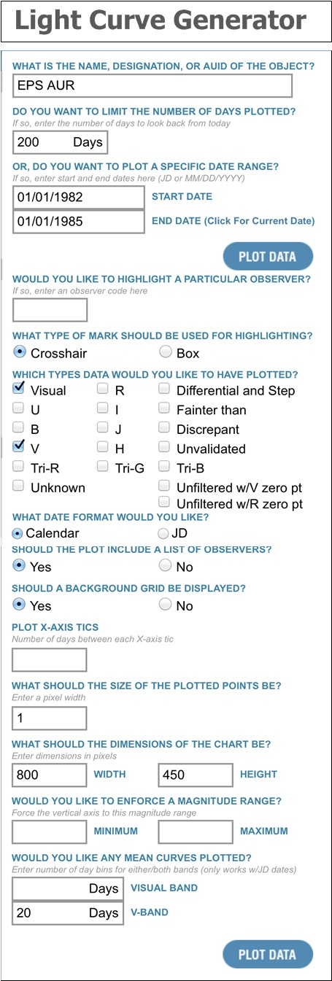
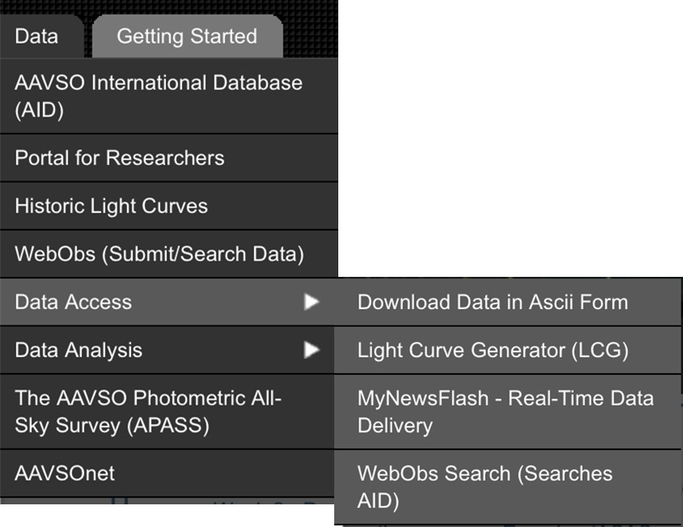
The online light curve generator is available by clicking on the Data tab at the top of the AAVSO home page, and then selecting Data Access, followed by Light Curve Generator.

The dialog box shown at the right hand side of this page will appear. This may look complicated but you can get started just by filling out the first two or three boxes: To plot a light curve, enter the abbreviated star name in the first field (as shown at the right) and enter the number of days or the date range you wish to cover [The date range can be entered in conventional format (as illustrated) or inJulian Date format]. Then click Plot Data. It’s that simple! The rest of the options are just that - optional.
For instance, if you have submitted observations of any of these stars to the AAVSO, you can type in your observer code here and your observations will be highlighted on the plot, allowing you to compare your observations with others.
Other options include the ability to select the types of data you would like to have plotted, whther you would like a mean curve to be plotted, and various options for tailoring the way the plot is presented.

Make Your Own Light Curves - Java

A more versatile and sophisticated software package called VStar, a visualisation and analysis tool, is available from the AAVSO website at the following URL:

http://www.aavso.org/vstar-overview
Simply click on the Download VStar Now button: 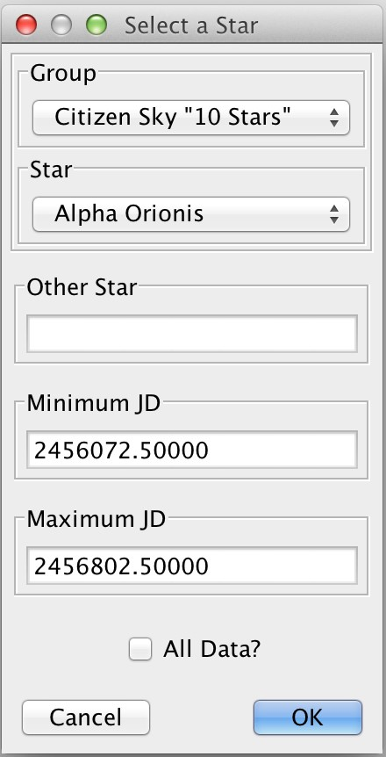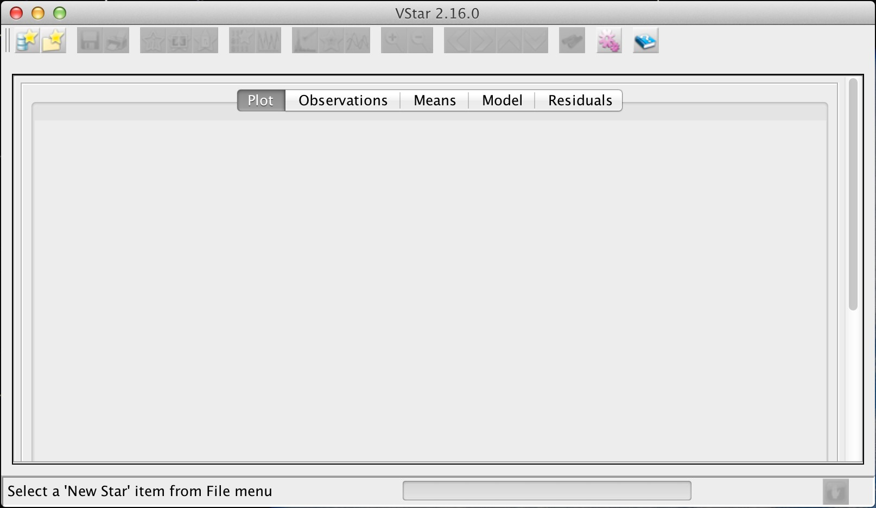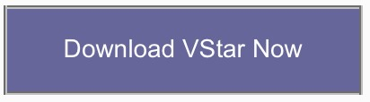
Click on
this button
to load data. You’ll be prompted for the star name
and a range of data you’d like to see, as shown in the dialog box on
the left. VStar currently requires this date range to be in Julian Date
format, but a future version will accept standard calendar dates. Until
then, you can convert calendar dates to Julian Dates at this URL:

http://www.aavso.org/jd-calculator

The software requires Java and has been tested on Windows, OS X, Linux and other platforms.
The program should launch directly from your web browser. There is no need to formally install it. The first time you run it, you will see something like this:

Make Your Own Mean Curves - Java
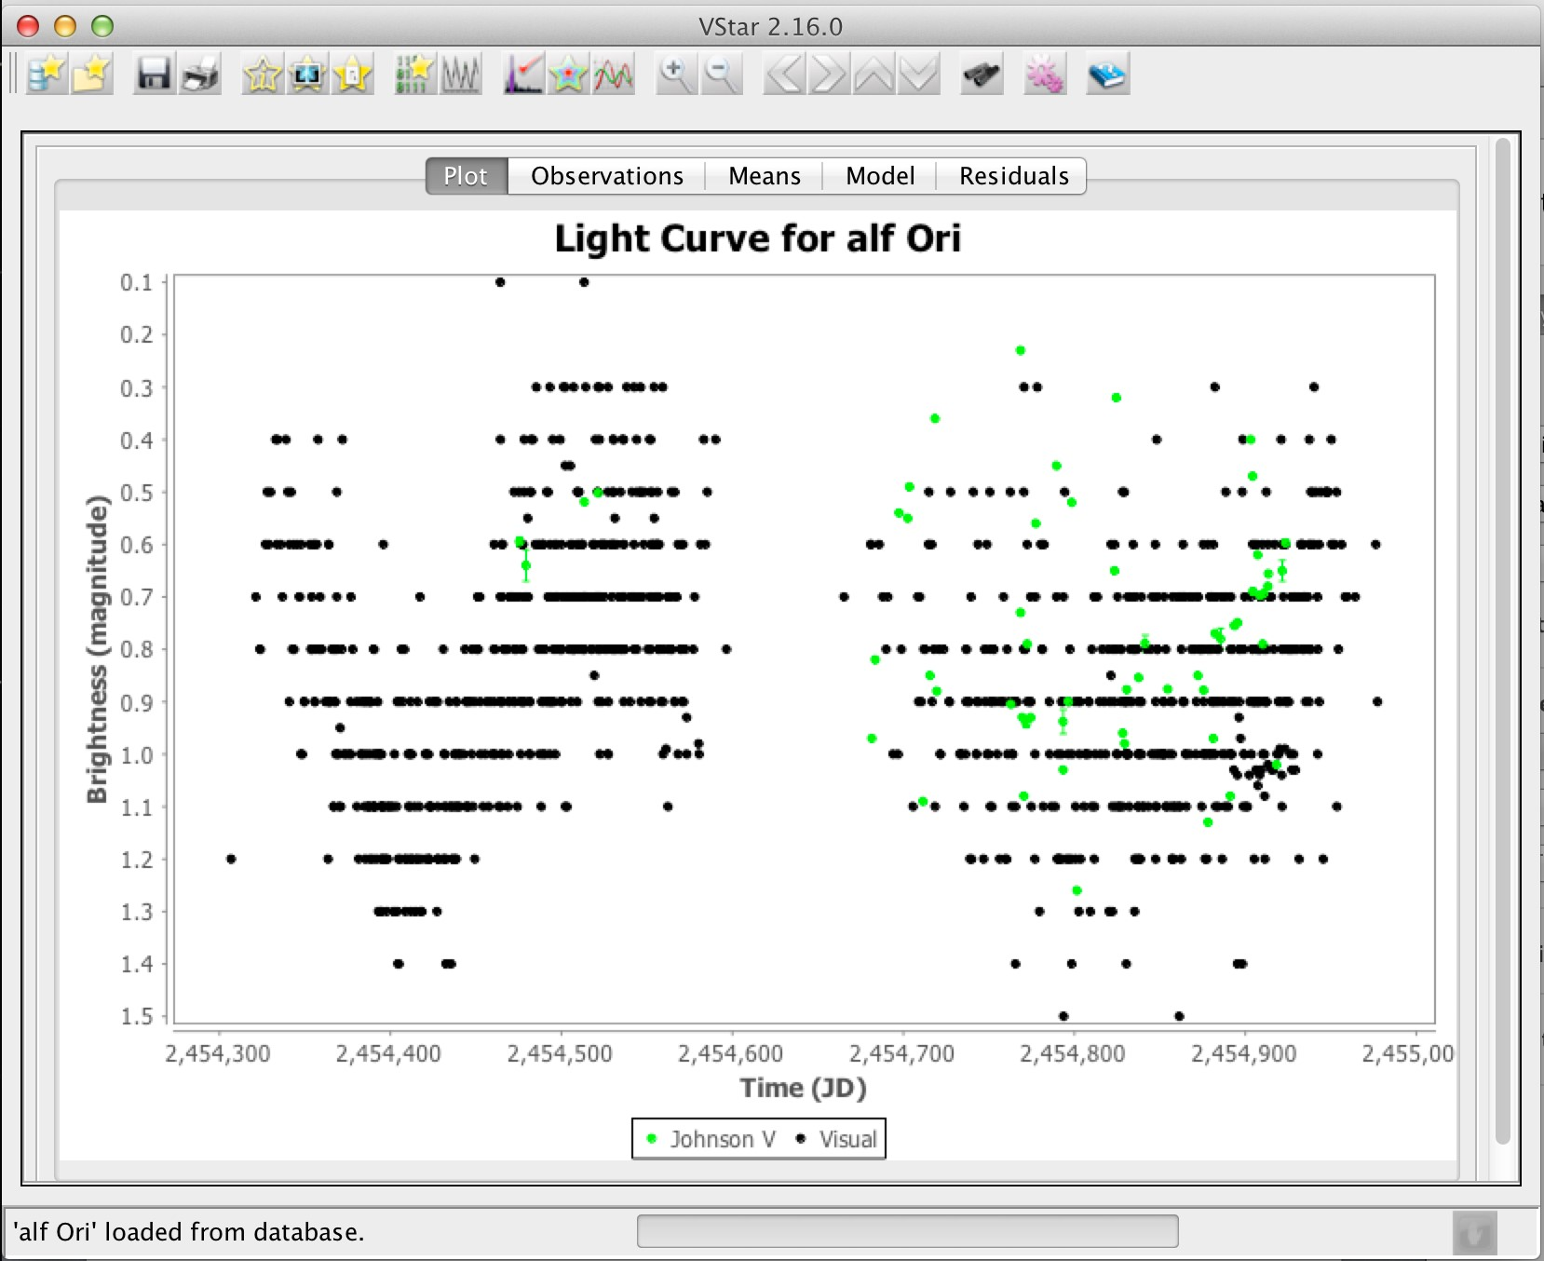
If this curve looks familiar, it is because it looks a lot like the one on page 1 of this tutorial. Except that now we have some green coloured dots. Those are photometric observations made by digital detectors instead of by the unaided human eye. You can add / remove this and other series by clicking on View then Plot Control. Note that a “series” is just a name for a collection of related data obtained over some time period.
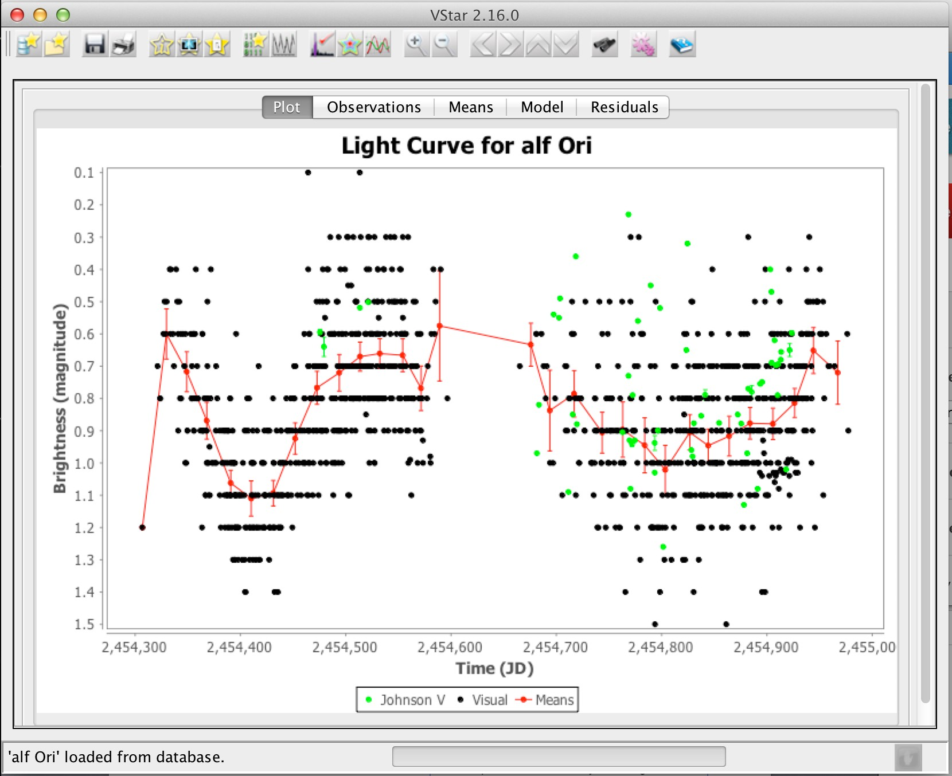
You can zoom in on a group of data just by drawing a box around it. You can zoom out by left-clicking anywhere on the graph.
You can plot a mean curve by selecting Plot Control from the View menu and then ticking the Means box under the Analysis heading. Type in different values in the Days per Mean Series Bin box to see how it affects the mean curve. This is a tricky part of analysis. How much can you manipulate the parameters before you are stretching your results?

Phase Diagrams

When the same cycle repeats over and over as regularly as clockwork, we refer to this as periodic behaviour. If a star (or any other phenomenon) is perfectly periodic, then its variation depends only on where it is in its cycle, a quantity called the phase. For example, a 24-hour clock repeats the same behaviour - with a period of one day. Each day the clock goes through one cycle, and each cycle is just like every other cycle. If we want to know what the clock reads, we do not need to know which day (cycle) it is, we just need to know the time of day (how far we are into the cycle). For example, 2:15 am is 2 hours and 15 minutes into the cycle of the day.
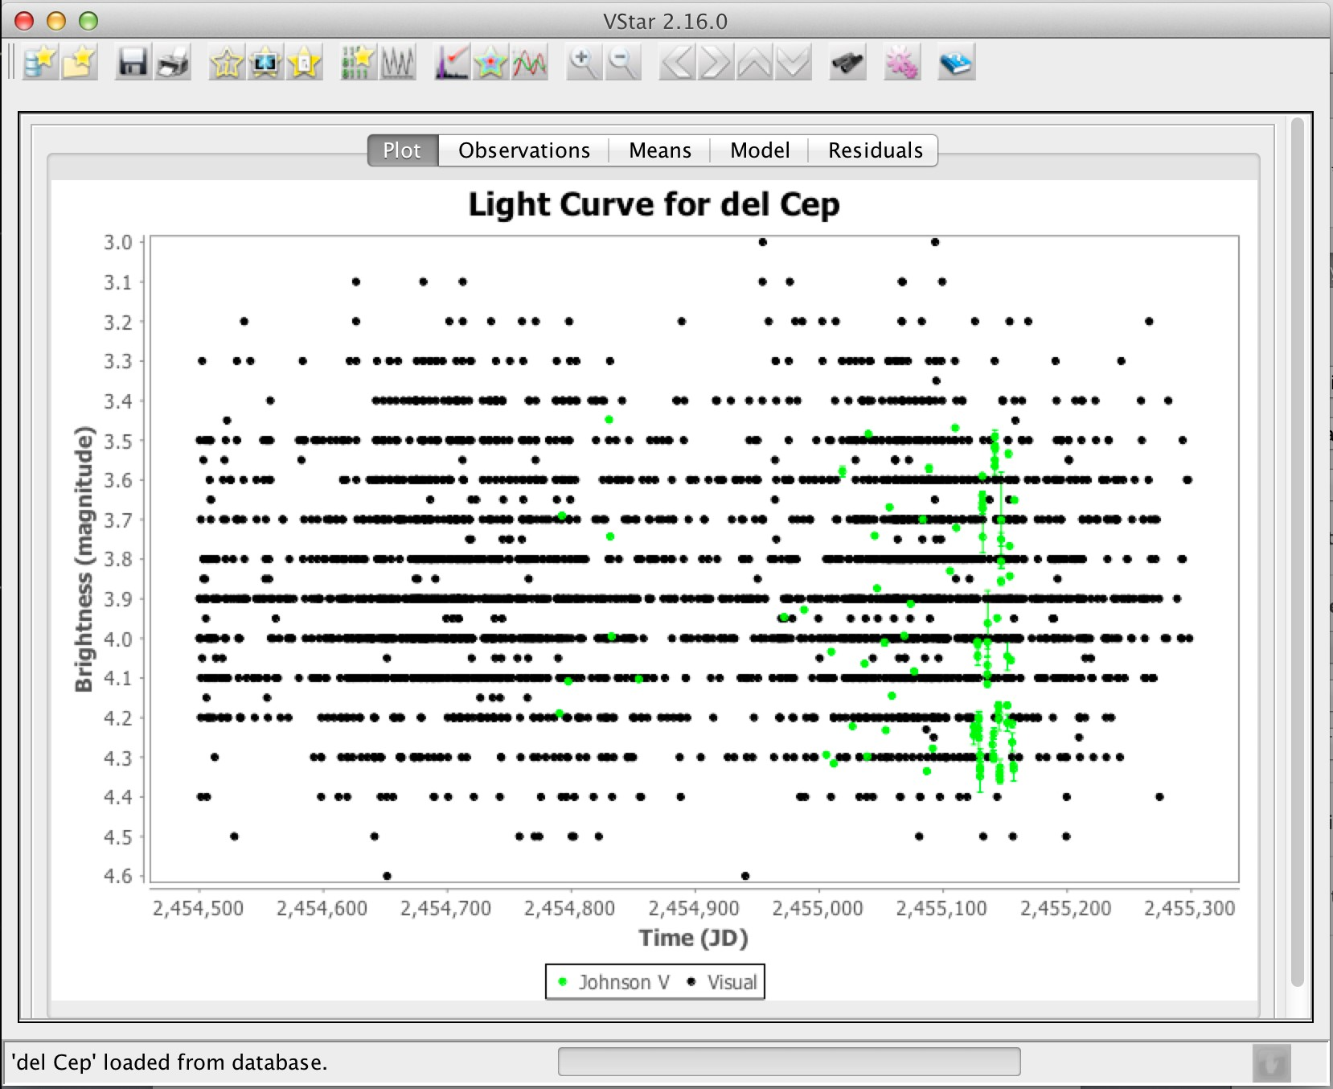
A phase diagram will “fold” a light curve on a certain period. This allows us to see the shape of the light curve as if all the data occurred in the same cycle.
Consider the light curve of delta Cephei to the right - it shows many cycles so it’s difficult to see its “real” shape.
To create a phase diagram, choose Phase Plot from the Analysis menu. For a first attempt, just accept the default Period and Epoch.

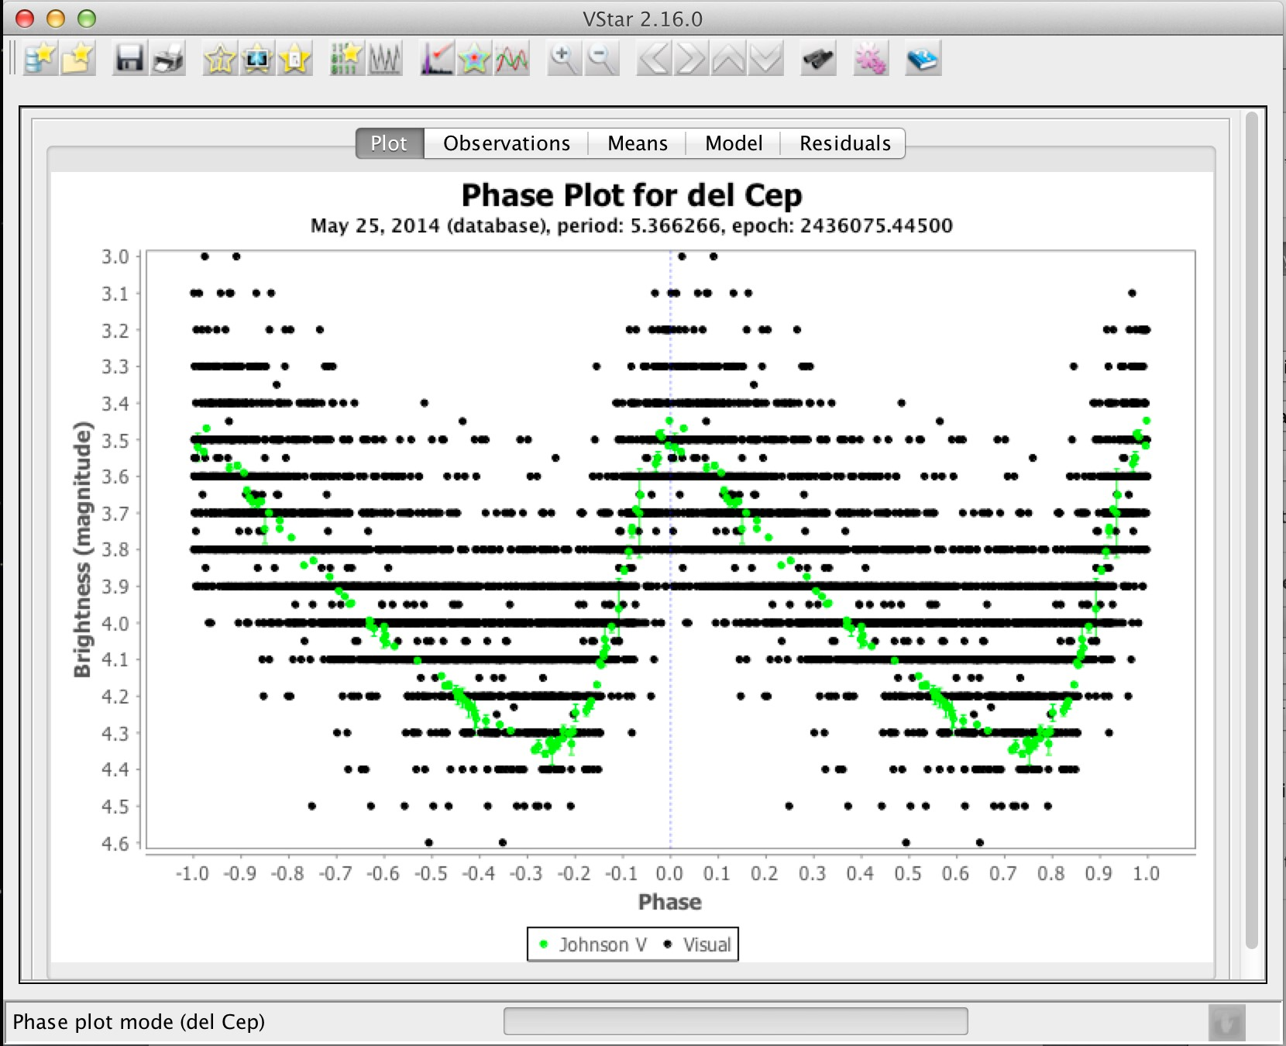
By using a phase diagram (right), we put all of the data onto one (fictional) cycle and can see the shape of the light curve quite well.
In this example, we can see that delta Cephei rises in magnitude very quickly, but takes much longer to drop in magnitude.

Much more information on phase diagrams is available in Chapter 12 of the AAVSO’s online curriculum Varaiable StarAstronomy, available at the following URL:

http://www.aavso.org/education/vsa

Period Analysis
One of the most important properties of a variable star is its period. Astronomers have lots of tools at their disposal to look for periods in variable star data. One of the most basic tools is the previously-mentioned phase diagram. A more advanced tool is Fourier Analysis*. VStar has several Fourier analysis options under the Analysis menu. Choose DC DFT Standard Scan and on the resultant graph, choose the Amplitude v Frequency tab. The graph below is the result of running a period search on delta Cephei.
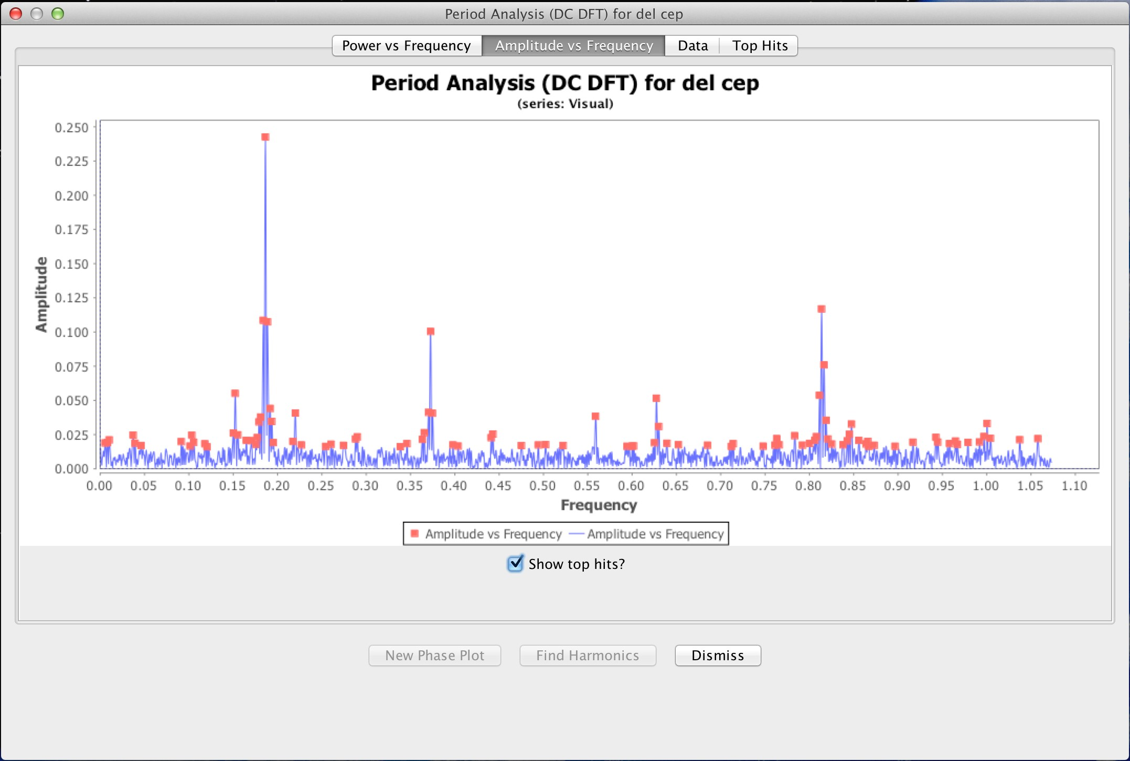

Amplitude is a measure of the change in brightness detected. The Frequency is the period in cycles per day. The pronounced peak around 0.2 means that delta Cephei completes a cycle every five days or so (1 divided by 0.2 = 5). In general, you should look for peaks that stand out above all their neighbours, as this one does.
* A full discussion of Fourier Analysis is beyond the scope of this tutorial. But a good start is an online time series tutorial written by Dr Matthew Templeton. It is available at this URL:
http://www.aavso.org/time-series-tutorial

